**9. ReactJS-HOL**

In this hands-on lab, you will learn how to:

* Use map() method of ES6
* Apply arrow functions of ES6
* Implement Destructuring features of ES6

**Steps:**  
Create a React Application named “cricketapp” with the two components:

1. **ListofPlayers**

* Declare an array with 11 players and store details of their names and scores using the map feature of ES6
* Filter the players with scores below 70 using arrow functions of ES6.

ListofPlayers.jsx

import React from 'react';

function ListofPlayers() {

const players = [

{ name: 'Jack', score: 50 },

{ name: 'Michael', score: 70 },

{ name: 'John', score: 40 },

{ name: 'Ann', score: 61 },

{ name: 'Elisabeth', score: 61 },

{ name: 'Sachin', score: 95 },

{ name: 'Dhoni', score: 100 },

{ name: 'Virat', score: 84 },

{ name: 'Jadeja', score: 64 },

{ name: 'Raina', score: 75 },

{ name: 'Rohit', score: 80 },

];

//below 70 score

const below70 = players.filter((item) => item.score < 70);

return (

<div style={{ padding: '20px' }}>

<h2>List of Players</h2>

<ul>

{players.map((item, index) => (

<li key={index}>

Mr. {item.name} {item.score}

</li>

))}

</ul>

<hr />

<h2>List of Players having Scores Less than 70</h2>

<ul>

{below70.map((item, index) => (

<li key={index}>

Mr. {item.name} {item.score}

</li>

))}

</ul>

</div>

);

}

export default ListofPlayers;

1. **IndianPlayers**
   1. Display the Odd Team Player and Even Team players using the Destructuring features of ES6.
   2. Declare two arrays, T20players and RanjiTrophy players and merge the two arrays and display them using the Merge feature of ES6

IndianPlayers.jsx

import React from 'react';

// a. Destructuring example

function OddPlayers({ players }) {

const [first, , third, , fifth] = players;

return (

<div>

<h2>Odd Players</h2>

<ul>

<li>First : {first}</li>

<li>Third : {third}</li>

<li>Fifth : {fifth}</li>

</ul>

</div> );}

function EvenPlayers({ players }) {

const [, second, , fourth, , sixth] = players;

return (

<div>

<h2>Even Players</h2>

<ul>

<li>Second : {second}</li>

<li>Fourth : {fourth}</li>

<li>Sixth : {sixth}</li>

</ul>

</div> );}

//merge the two arrays

function IndianPlayers() {

const allPlayers = ['Sachin1', 'Dhoni2', 'Virat3', 'Rohit4', 'Yuvaraj5', 'Raina6'];

const T20Players = ['First Player', 'Second Player', 'Third Player'];

const RanjiTrophyPlayers = ['Fourth Player', 'Fifth Player', 'Sixth Player'];

const mergedPlayers = [...T20Players, ...RanjiTrophyPlayers];

return (

<div>

<OddPlayers players={allPlayers} />

<EvenPlayers players={allPlayers} />

<h2>List of Indian Players Merged:</h2>

<ul>

{mergedPlayers.map((player, index) => (

<li key={index}>Mr. {player}</li>

))}

</ul>

</div> );}

export default IndianPlayers;

**3. Edit the App.js**:

App.js

import React from 'react';

import IndianPlayers from './components/IndianPlayers';

import ListofPlayers from './components/ListofPlayers';

function App() {

const flag = false;

return (

<div className="App">

<h1>Cricket Players Info</h1>

{flag ? <ListofPlayers />:<IndianPlayers />}

</div>

);

}

export default App;

**4. Run the application:**

npm command: npm start

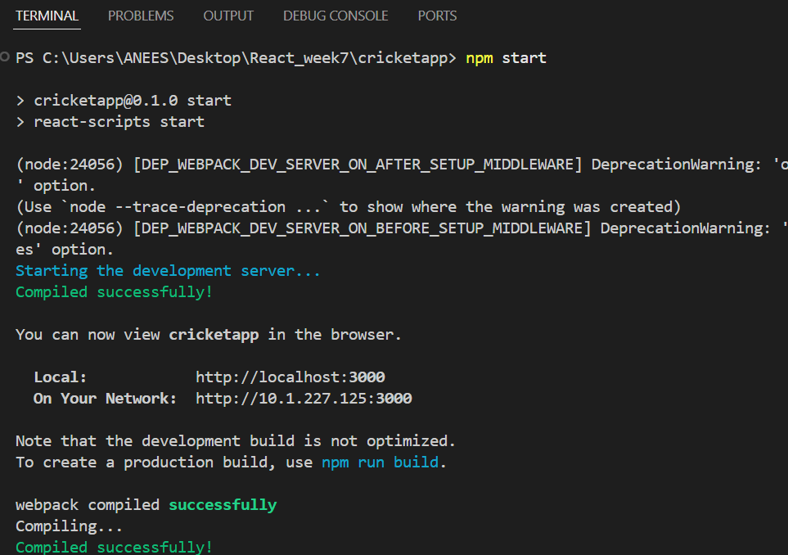

**Output:**

When flag=true

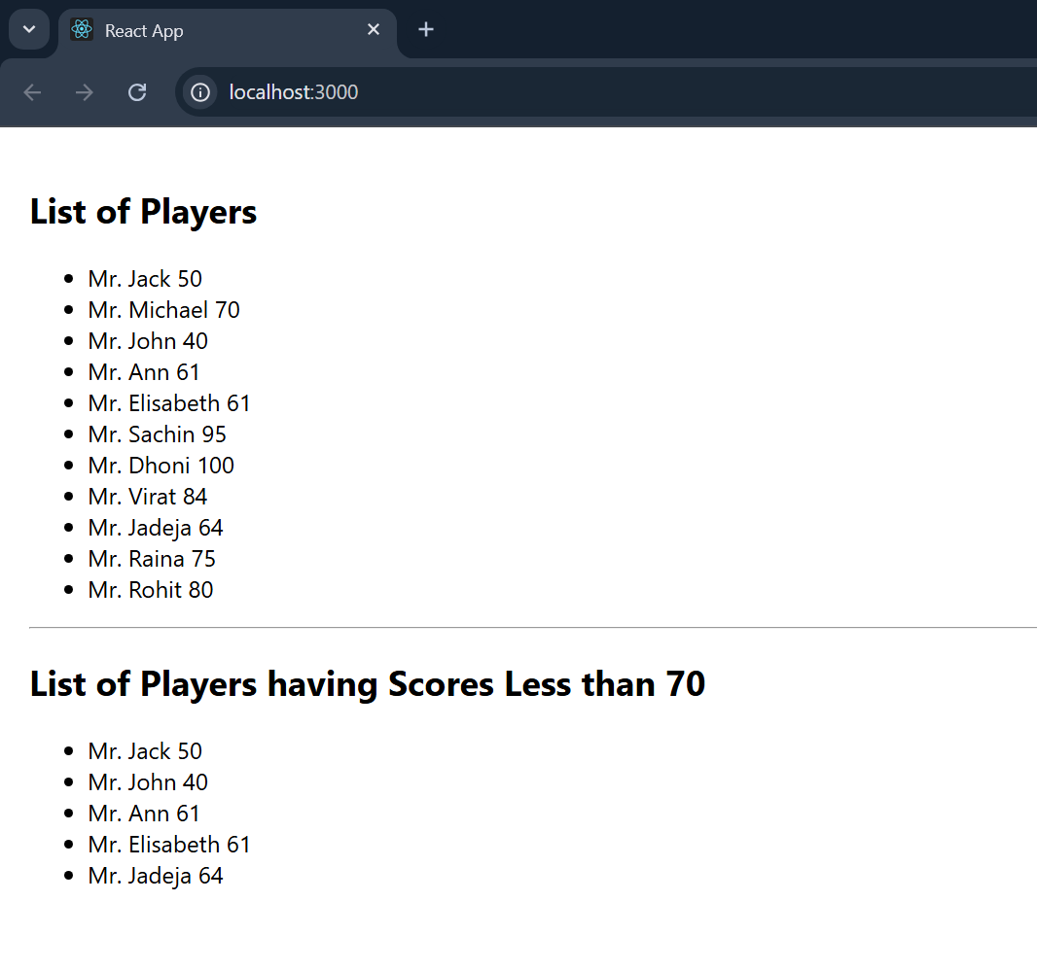

When flag=false

